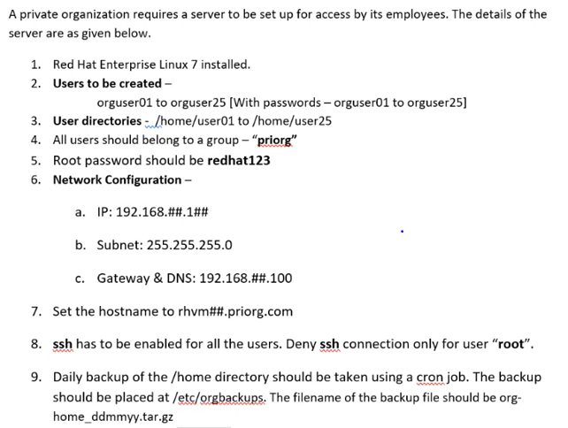

2.users creation:

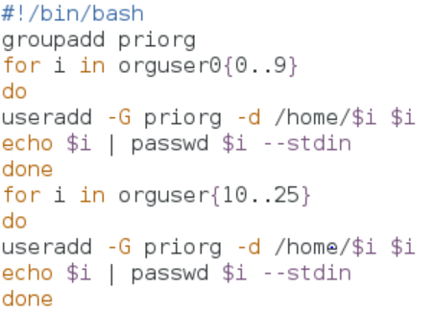

3.user directories:

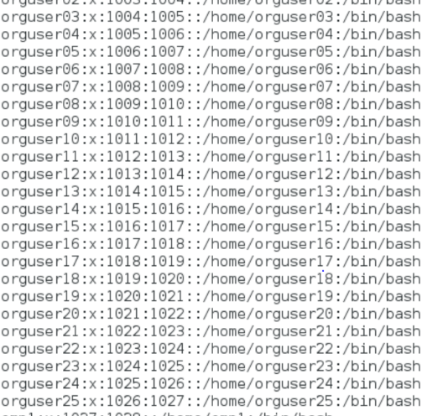

4.users should belong to group priorg:

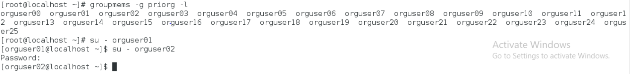

5.root password change:

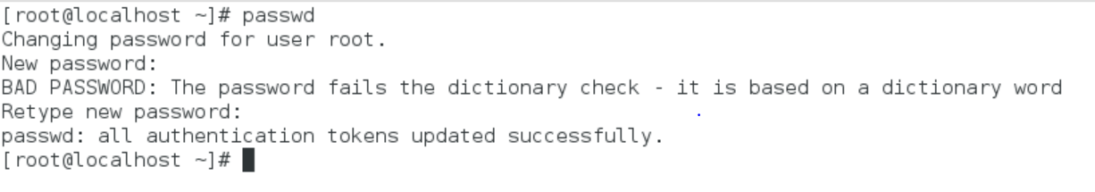

6.network configuration:

Ip address, subnetmask

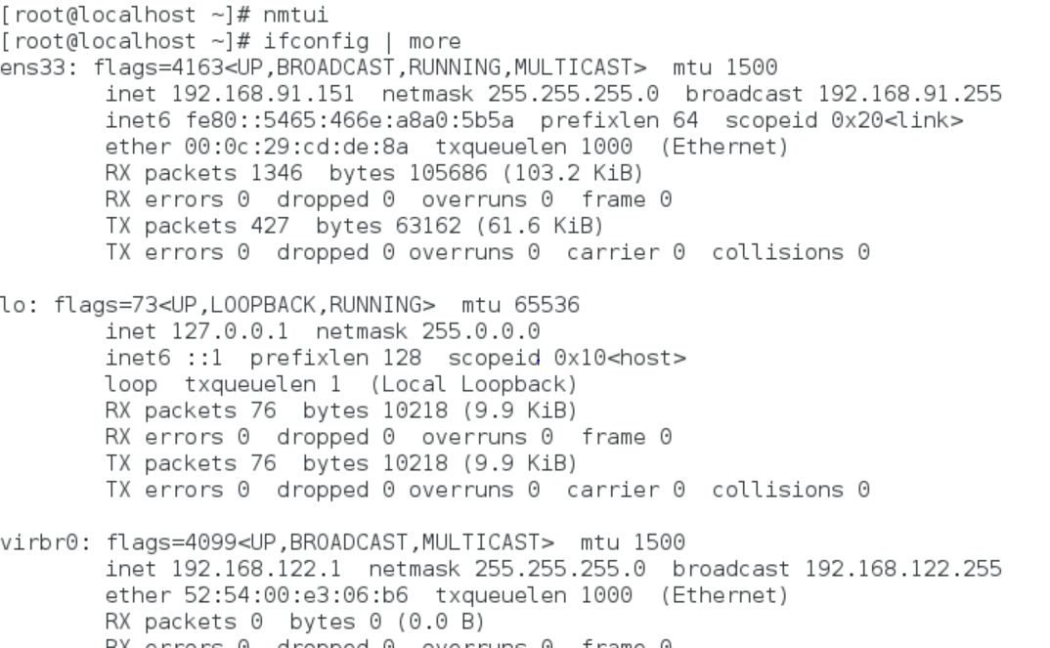

Gateway and DNS:

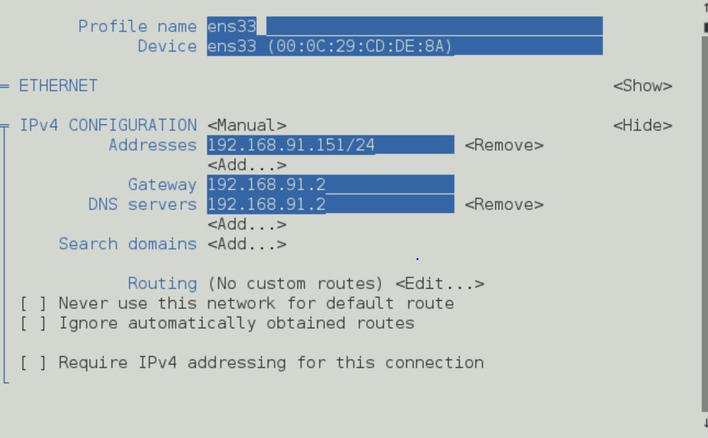

7.set hostname:

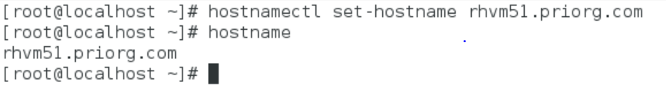

8.ssh deny root user login & allow other users:

C:\Users\srinija.puvvula\Desktop\ss.PNG

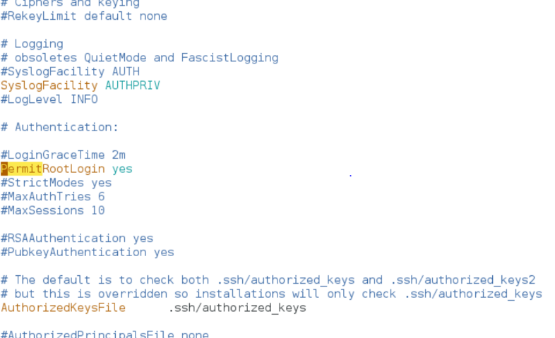

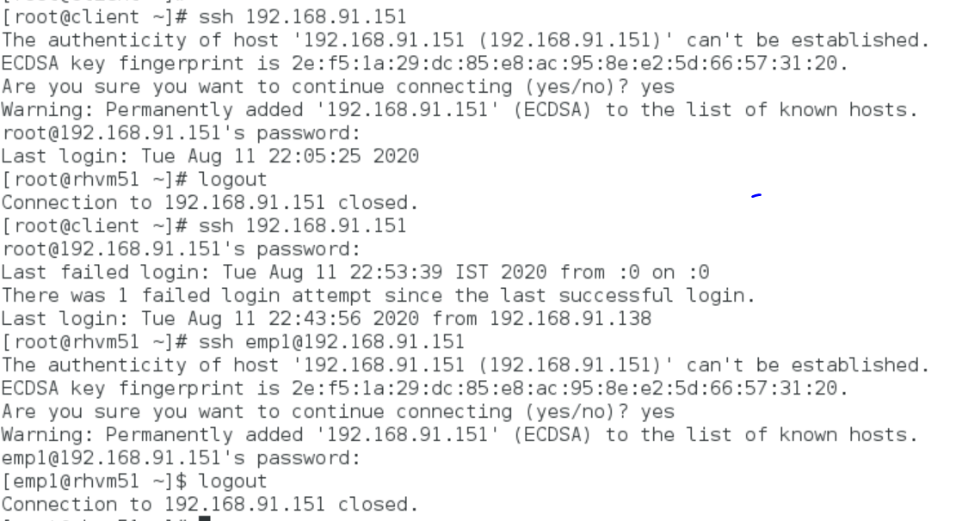

9.daily backup:



